Lab 1: Ohm’s Law, KVL, and Voltage Divider Rule using Series Circuit

|  |  |
| --- | --- |
| Submitted By | Name: Townim Faisal  ID: 1721327042  Section: 08  Group: 07 |

**Experiment 1**

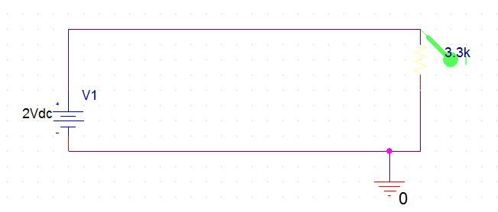

Figure: circuit for experiment 1

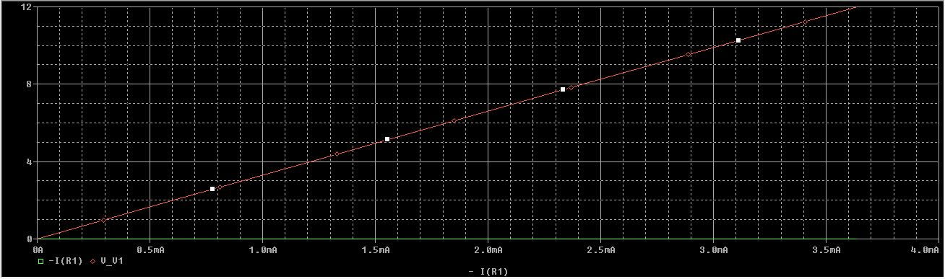

Figure: Plot V(voltage) vs I(mA)

**Experiment 2**

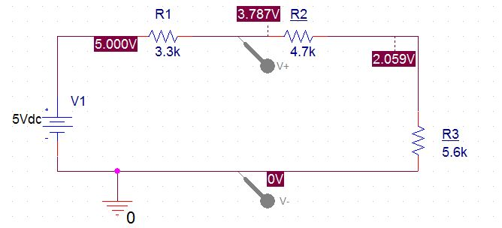

Figure: For 5 volt

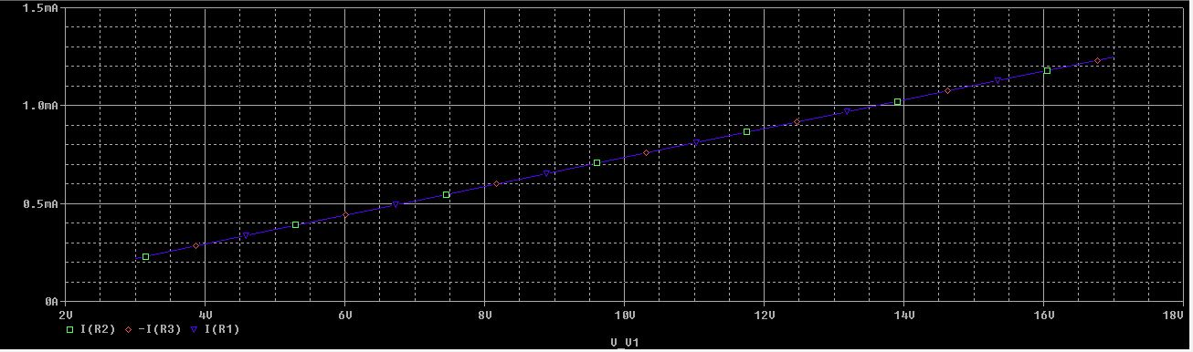

Figure: Voltage source vs I_R1, I_R2, I_R3

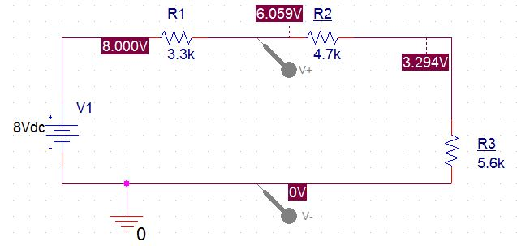

Figure: for 8V

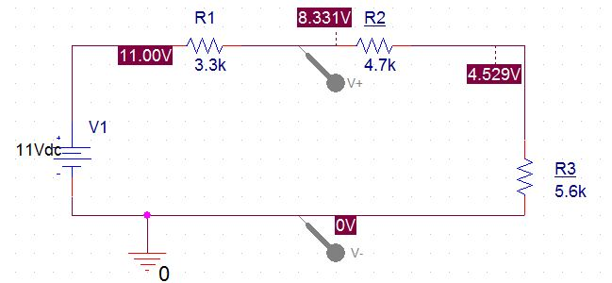

Figure: For 11 V

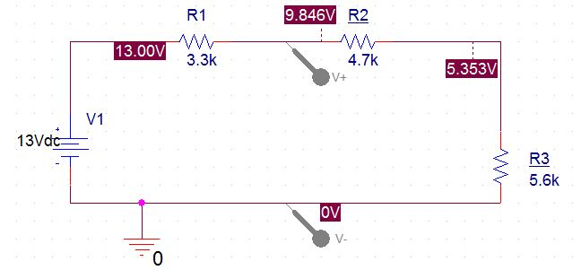

Figure: For 13 v

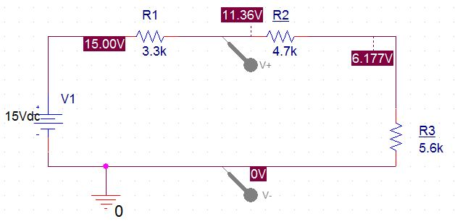

Figure: For 15v